

AI-Based Skin Allergy Detection and Personalized Healthcare Recommendation System Using Deep Learning

FINAL YEAR
PROJEECT PHASE-I REPORT
Submitted by Janani.R(23619210)
Kaviyashree K(23619244)
Poojasree.PD (23619223)
in Partial fulfillment for the award of the degree of

BACHELOR OF TECHNOLOGY CSE IN


ARTIFICIAL INTELLIGENCE AND MACHINE LEARNING
DEPARTMENT OF ARTIFICIAL INTELLIGENCE AND MACHINE LEARNING
SCHOOL OF ENGINEERING
VELS INSTITUTE OF SCIENCE, TECHNOLOGY AND ADVANCED STUDIES
(VISTAS)
CHENNAI
OCTOBER 2026

BONAFIDE CERTIFICATE

Certified that this project “AI-BASED SKIN ALLERGY DETECTION AND PERSONALIZED HEALTHCARE RECOMMENDATION SYSTEM USING DEEP LEARNING” is the bonafide work of Poojasree.PD (23619223), Janani.R (23619210), Kaviyashree (23619244) who carried out the project under my supervision. Certified further, that to the best of my knowledge the work reported here does not form part of any other project report or dissertation on the basis of which a degree or award was conferred on an earlier occasion on this or any other candidate.

SIGNATURE OF THE HOD SIGNATURE OF THE SUPERVISOR
Dr. K. Ulagapriya M.E., Ph.D Mrs. S.Divya Bairavi ,M.E.(Ph.D),
Associate Professor & Head Assistant Professor
Department of AI & ML Department of AI & ML
School of Engineering School of Engineering
VISTAS VISTAS
Chennai Chennai

Submitted for the Project Work and Viva - Voce examination held on at Vels Institute of Science, Technology and Advanced Studies (VISTAS), Chennai – 600 117.

INTERNAL EXAMINER EXTERNAL EXAMINER

ACKNOWLEDGEMENT

It is certainly a great delight and proud privilege to acknowledge the help and support I received from the positive minds around me in making this venture a successful one. The infrastructural support with all kinds of lab facilities have been a motivating factor in this completion of project work, all because of FOUNDER & CHAIRMAN, Shri. Dr. ISHARI K. GANESH., with great pleasure that I take this opportunity to thank him. I am grateful to our HEAD OF THE DEPARTMENT, Dr. K. Ulagapriya., for her continuous support for the project, from initial advice and contacts in the early stages of conceptual inception, and through on-going advice and encouragement to this day. I extend our warmest thanks to my INTERNAL GUIDE, S.Divya Bairavi M.E.,(Ph.D), who has patiently guided and provided us with invaluable advice and help. I am thankful to my Project Coordinator Ms. Sowmiya.S.M M.E.,(Ph.D), I would like to express my greatest gratitude to our Staff members, Librarian, and Non-teaching staff members of Computer Centre, who have helped and supported me throughout. Last but not the Least, I wish to thank my parents and my friends for their individual support and interest who has inspired me and encouraged me to go in my own way, without them I would be unable to complete this project.

KAVIYASHREE K (23619244)

POOJASREE PD (23619223)

JANANI R (23619210)

SL.NO | TITLE | PAGE NO
 | ABSTRACT | 10
01 | INTRODUCTION  - GENERAL  - PROBLEM STATEMENT  - OBJECTIVE  - MODULES  - SUMMARY | 11
02 | LITERATURE SURVERY  - GENERAL  - EXISTING SYSTEM  - PROPOSED SYSTEM  - SUMMARY | 14
03 | METHODOLOGY  - SYSTEM REQUIREMENT  - SYSTEM ARCHITECTURE OF THE PROPOSED MODEL  - DESCRIPTION OF MODULES  - DATA COLLECTION & DATA PREPROCESSING  - SKIN CONDTION DETECTION MODEL  - PROPOSED METHODOLOGY  - SUMMARY | 17
04 | SYSTEM IMPLEMENTATION  - GENERAL  - SYSTEM WORKFLOW  - OVERVIEW OF THE PLATFORM  - MODULE IMPLEMENTATION  - SUMMARY | 24

05 | EXPERIMENTAL ANALYSIS  - EXPERIMENTAL SETUP  - PERFORMANCE EVALUATION  - COMPARSION WITH EXISTING WORK  - RESULT & DISCUSSION  - SUMMARY | 32
06 | CONCLUSION AND FUTURE WORK  - CONCLUSION  - LIMITATION OF CURRENT WORK  - FUTURE ENHANCEMENT  - SUMMARY | 44
07 | REFERNCES | 46
08 | SOURCE CODE | 48
09 | CONFERENCE APPLICATION | 74

LIST OF FIGURES

Figure No. | Title | Page No.
Fig. 3.1 | Integrated Architecture of Skin Allergy Detection and Personalized Healthcare Recommendation System | 19
Fig. 4.1 | System Workflow Diagram | 25
Fig. 4.3 | Output of Skin Allergy Detection and Personalized Healthcare Recommendation System | 30
Fig. 5.1 | System Architecture of AI-Based Skin Allergy Detection and Personalized Healthcare Recommendation | 33
Fig. 5.2 | Predicted Condition and Confidence Across Four Sample Uploads | 37

LIST OF TABLES

Table No. | Title | Page No.
Table 3.1 | Hardware Requirements | 17
Table 3.2 | Software Requirements | 18
Table 3.3 | Skin Condition Classes | 18
Table 3.4 | Image Preprocessing | 18
Table 3.5 | Model Configuration | 22
Table 5.1 | Dataset Splitting Strategy | 33
Table 5.2 | Prediction Confidence | 36
Table 5.3 | Evaluation Features | 36
Table 5.4 | Comparison of Existing System and Proposed System | 39

LIST OF ABBREVIATIONS

Abbreviation | Full Form
AI | Artificial Intelligence
ML | Machine Learning
CNN | Convolutional Neural Network
RGB | Red, Green, Blue
PDF | Portable Document Format
RAM | Random Access Memory
PIL | Python Imaging Library
Grad-CAM | Gradient-weighted Class Activation Mapping

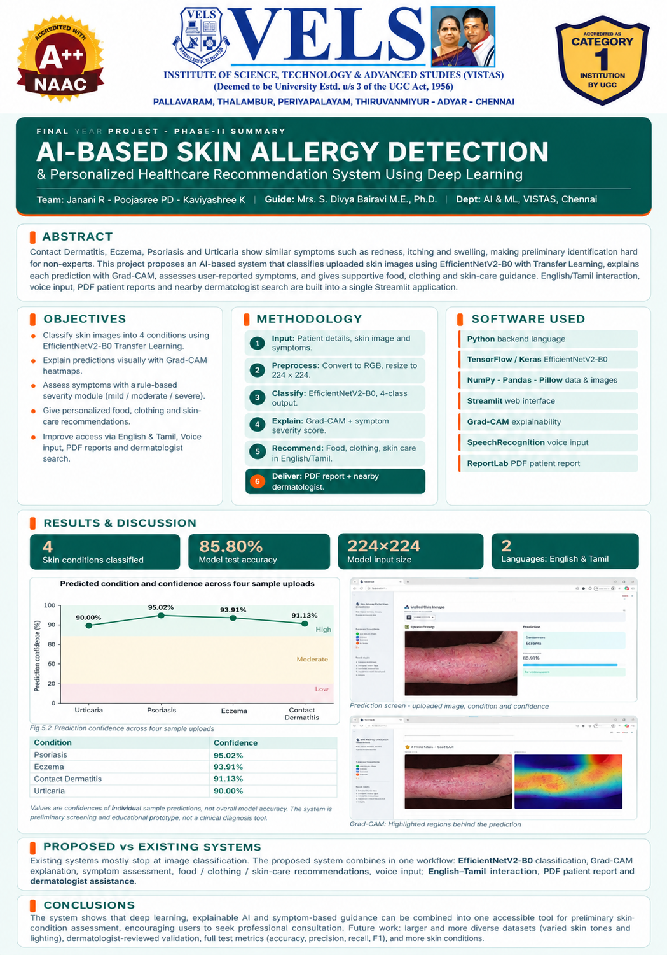

Abstract:

Skin-related conditions such as Contact Dermatitis, Eczema, Psoriasis, and Urticaria often exhibit similar symptoms, including redness, itching, swelling, irritation, and changes in skin appearance, making preliminary identification difficult for non-specialists. This paper presents DermaAI, an AI-based skin allergy detection and personalized healthcare recommendation system that integrates deep learning with a comprehensive patient-support workflow. The proposed system employs the EfficientNetV2-B0 model with transfer learning to classify skin images into four predefined skin conditions. To improve transparency and interpretability, Gradient-weighted Class Activation Mapping (Grad-CAM) is incorporated to highlight the image regions that contribute to the model's prediction. In addition to image-based classification, a rule-based symptom assessment module evaluates six user-provided symptoms, including itching, redness, swelling, pain or discomfort, affected area, and skin changes, to estimate the severity of the detected condition.The system further provides personalized recommendations on food, clothing, and skin care based on the predicted skin condition. To enhance accessibility and user experience, the application supports bilingual interaction in English and Tamil, voice-based symptom assistance, downloadable PDF patient report generation, and nearby dermatologist location support. The application is developed using Python, TensorFlow/Keras, and Streamlit, providing an intuitive interface for uploading skin images, entering patient information, analyzing symptoms, and viewing prediction results. Experimental evaluation demonstrates that the EfficientNetV2-B0 model achieves a test accuracy of 85.80% for four-class skin condition classification. The proposed system serves as an educational and preliminary screening tool to improve patient awareness and encourage timely medical consultation. It is not intended to replace professional diagnosis by dermatologists. Future work will focus on validating the system using larger and more diverse clinical datasets and dermatologist-reviewed cases to improve reliability, robustness, and practical applicability.

Keywords— Artificial Intelligence (AI), Skin Allergy Detection, Deep Learning, EfficientNetV2-B0, Transfer Learning, Grad-CAM, Personalized Healthcare Recommendation, Medical Image Classification, Streamlit.

CHAPTER 1
- Introduction:

GENERAL
Skin health is an important part of overall well-being, and skin-related conditions can affect people of different age groups. Common conditions such as Contact Dermatitis, Eczema, Psoriasis, and Urticaria may produce symptoms such as redness, itching, irritation, swelling, and changes in skin appearance. Due to the similarity of these symptoms, preliminary identification can be difficult for people without proper medical knowledge. The use of Artificial Intelligence and Deep Learning provides an opportunity to analyse skin images and assist users in obtaining preliminary information about their skin condition.

Despite the availability of healthcare services, people may face difficulties in obtaining immediate dermatological consultation. Many users depend on online searches or informal information to understand visible skin problems, which may not provide a structured analysis. Basic image classification systems may also provide only a predicted condition without explaining the important regions of the image or considering the user's reported symptoms. Therefore, there is a need for an accessible system that can combine image analysis with additional supportive information.

Another major challenge is providing useful guidance after identifying a possible skin condition. Different conditions may require different supportive considerations related to food, clothing, and skin care. Users may also face difficulties in communicating symptoms or maintaining a record of their preliminary assessment. Features such as symptom assessment, visual explanation, multilingual interaction, report generation, and dermatologist assistance can make an AI-based system more useful and accessible.

Therefore, there is a strong need for a comprehensive AI-based skin condition assessment system that combines deep learning, visual explanation, symptom assessment, and personalized supportive recommendations. The proposed system uses EfficientNetV2-B0 with Transfer Learning to classify skin images into four predefined conditions and integrates Grad-CAM, rule-based symptom assessment, recommendations, bilingual interaction, patient report generation, and nearby dermatologist assistance. The system is designed as a preliminary screening and educational prototype to support users while encouraging appropriate professional consultation.

PROBLEM STATEMENT
The identification of skin conditions is a challenging task because different conditions may have similar visual symptoms such as redness, itching, irritation, swelling, and changes in skin appearance. Conditions such as Contact Dermatitis, Eczema, Psoriasis, and Urticaria can therefore be difficult to distinguish through simple visual observation, especially for people without medical knowledge.

Another major problem is the limited availability of immediate dermatological consultation and the lack of an easy-to-use system for preliminary skin analysis. People may depend on online searches or informal information to understand their skin problems. These methods may not provide a systematic analysis of the affected skin image. Basic image classification systems may also provide only the predicted condition without explaining the prediction or considering the user's symptoms.
Therefore, there is a need for a comprehensive AI-based solution that can analyse skin images and provide meaningful preliminary information. The system should combine deep learning-based classification with visual explanation, symptom assessment, personalized food and clothing recommendations, and supportive-care guidance to provide a more complete user experience.

The proposed system aims to address these challenges by integrating EfficientNetV2-B0-based skin condition detection, Grad-CAM visualization, rule-based symptom assessment, personalized recommendations, multilingual interaction, report generation, and dermatologist assistance in a single platform. This can help users understand the preliminary result more easily while encouraging appropriate professional consultation when required.

OBJECTIVE
The main objective of this project is to design and develop an AI-based skin condition detection system that can analyse uploaded skin images and provide preliminary information about common skin conditions. The system focuses on Contact Dermatitis, Eczema, Psoriasis, and Urticaria, helping users understand their skin condition through an easy-to-use application.
Another important objective of the project is to use Deep Learning and Transfer Learning with EfficientNetV2-B0 for skin image classification. The system also aims to use Grad-CAM to provide visual explanations of the prediction and a rule-based approach to assess user-provided symptoms. This helps provide a more structured understanding of the preliminary prediction.
The project also focuses on providing personalized supportive recommendations based on the predicted skin condition. These recommendations include general guidance related to food, clothing, and supportive skin care. The system also aims to improve accessibility through English and Tamil interaction and voice-based symptom input.
Furthermore, the system seeks to provide additional support through patient report generation and nearby dermatologist assistance. By integrating prediction, explanation, symptom assessment, and supportive recommendations into a single platform, the project aims to provide a convenient preliminary skin assessment system. Overall, the system is intended to support users with preliminary information while encouraging appropriate professional consultation when required.

MODULES

The scope of this project focuses on developing an AI-based skin condition detection and personalized healthcare recommendation system. The system is designed to analyse uploaded skin images and classify them into four predefined conditions: Contact Dermatitis, Eczema, Psoriasis, and Urticaria.

The project includes a skin image preprocessing and classification module using EfficientNetV2-B0 with Transfer Learning. It also incorporates Grad-CAM visualization to explain the important regions considered during prediction and a symptom assessment module to analyse user-provided symptoms. These features help provide a more structured preliminary assessment of the skin condition.
The system also provides personalized supportive recommendations related to food, clothing, and skin care based on the predicted condition. Additional features such as English and Tamil interaction, voice-based symptom input, patient report generation, and nearby dermatologist assistance are included to improve accessibility and user convenience.
However, the scope of this project is limited to the four predefined skin conditions and the available dataset. The system is intended as a preliminary screening and educational prototype and does not provide clinical diagnosis. Large-scale clinical deployment, extensive dermatologist validation, and integration with advanced healthcare systems are considered for future enhancement.

SUMMARY
This chapter discussed the background and key challenges involved in identifying common skin conditions. It highlighted the difficulties in distinguishing Contact Dermatitis, Eczema, Psoriasis, and Urticaria, the limited availability of immediate dermatological consultation, and the need for an accessible system that can provide preliminary skin analysis.
The objectives of the project were outlined, focusing on developing an AI-based skin condition detection system, using EfficientNetV2-B0 for image classification, Grad-CAM for visual explanation, symptom assessment, and personalized supportive recommendations. The scope of the project was also defined, including features such as bilingual interaction, voice-based symptom input, patient report generation, and dermatologist assistance.
Overall, this chapter establishes the foundation for the proposed system, which aims to provide preliminary skin condition identification, visual explanation, symptom assessment, and supportive healthcare guidance through an integrated and user-friendly platform.

CHAPTER 2

- LITERATURE SURVEY

GENERAL
Skin condition detection has been widely studied in recent years due to the increasing use of Artificial Intelligence and Deep Learning in healthcare applications. Researchers have focused on developing automated image-based systems to identify different skin conditions and support preliminary assessment. Deep learning models can analyse skin images, identify visual patterns, and assist in classifying different conditions.
Several studies have explored the use of Convolutional Neural Networks (CNNs) and transfer learning techniques for skin disease classification. Pre-trained models such as EfficientNet and other CNN architectures have been used to extract important visual features from skin images. These approaches can improve classification performance while reducing the need to train a complete deep learning model from the beginning.
In addition, researchers have focused on explainable AI techniques to make deep learning predictions easier to understand. Methods such as Grad-CAM can highlight important regions of an input image that influence the model's prediction. This provides additional visual information instead of presenting only the predicted skin condition.
Other studies have explored supporting features such as symptom assessment and personalized healthcare recommendations. These approaches can provide additional information related to the user's symptoms and general supportive care. However, many existing systems mainly focus on image classification and do not combine prediction, visual explanation, symptom assessment, and personalized recommendations in a single application.
Therefore, there is a need for a more comprehensive system that integrates deep learning-based skin condition classification, explainable prediction, symptom assessment, and personalized supportive recommendations. This gap in existing approaches motivates the development of the proposed system.

EXISTING SYSTEM

Several research works have been carried out to improve skin condition detection using modern Artificial Intelligence and Deep Learning techniques. Many studies focus on the application of Convolutional Neural Networks (CNNs) and transfer learning models for analysing skin images and classifying different skin conditions.

In addition to image classification, researchers have explored deep learning-based skin disease detection systems using pre-trained models. Models such as EfficientNet and other CNN architectures have been used to improve feature extraction and classification performance. While these systems can provide useful predictions, many of them mainly focus on classification and do not provide additional supportive information to the user.

Some studies have also focused on explainable AI techniques for healthcare image analysis. Methods such as Grad-CAM can highlight important regions of an input image that influence the model's prediction. These approaches improve the interpretability of deep learning systems. However, visual explanation is not always integrated with symptom assessment and personalized recommendations in a single application.

Furthermore, recent research has explored additional healthcare support features such as symptom analysis and personalized recommendations. Although these approaches provide useful information, many existing systems implement such features separately and may not provide a complete workflow combining image prediction, explanation, symptom assessment, and supportive guidance.

Therefore, there is a clear need for a comprehensive system that integrates skin image classification, Grad-CAM-based visual explanation, symptom assessment, and personalized supportive recommendations into a single platform. The proposed system aims to address these limitations by providing an integrated and user-friendly preliminary skin condition assessment system.

PROPOSED SYSTEM
The proposed system is an AI-Based Skin Allergy Detection and Personalized Healthcare Recommendation System that uses Deep Learning to provide preliminary identification of common skin conditions. The system analyses an uploaded skin image and classifies it into one of four predefined conditions: Contact Dermatitis, Eczema, Psoriasis, and Urticaria.
The system uses EfficientNetV2-B0 with Transfer Learning for skin image classification. The uploaded image is prepared in the required format and processed by the trained model to generate the predicted condition. Grad-CAM is also integrated to highlight important regions of the image and provide a visual explanation of the prediction.
In addition to image classification, the proposed system includes a rule-based symptom assessment module that considers user-provided symptoms. Based on the predicted condition and available information, the system provides general food, clothing, and supportive-care recommendations. These features provide additional guidance instead of limiting the system to simple image classification.
The proposed system also provides English and Tamil interaction, voice-based symptom input, patient report generation, and nearby dermatologist assistance. These features are integrated into a single workflow to improve accessibility and user convenience. The system is developed using Python, TensorFlow/Keras, and Streamlit and is intended as a preliminary screening and educational prototype rather than a replacement for professional medical consultation.

SUMMARY
This chapter discussed the existing approaches used for skin condition detection using Artificial Intelligence and Deep Learning techniques. It highlighted the use of CNNs, transfer learning, pre-trained models, and explainable AI methods such as Grad-CAM. The limitations of existing systems, including their focus mainly on image classification and lack of integrated supportive features, were also identified.
The proposed system was introduced as an integrated platform that combines EfficientNetV2-B0-based skin condition detection, Grad-CAM visualization, symptom assessment, and personalized supportive recommendations. Additional features such as bilingual interaction, voice-based symptom input, patient report generation, and dermatologist assistance were also considered. Overall, this chapter establishes the need for the proposed system and provides the foundation for its methodology and implementation.

CHAPTER 3
  - METHODOLOGY:

SYSTEM REQUIREMENTS
The successful implementation of the proposed system requires both hardware and software components that support image processing, deep learning model execution, user interaction, and system integration. These requirements ensure that the system can analyse skin images efficiently and provide the required preliminary assessment and supportive recommendations.

A. Hardware Requirements
The system does not require high-end hardware and can be implemented using a standard computer or laptop. The basic hardware requirements include a computer with a minimum of 4 GB RAM, a multi-core processor, and sufficient storage capacity to handle the skin image dataset, trained model, and application files. A stable internet connection may be required for features such as accessing nearby dermatologist information.
Component | Requirement
Processor | Multi-core processor
RAM | Sufficient RAM for model execution
Storage | Sufficient storage for dataset and model
Display | Standard monitor
Internet | Required for selected support features
Table 3.1. Hardware Requirements

B. Software Requirements
The software requirements include tools and technologies used for developing and implementing the system. The system is developed using python for application development and model processing. TensorFlow/Keras is used for implementing the EfficientNetV2-B0 deep learning model, while NumPy, Pandas, and Pillow (PIL) support data processing and image handling. Grad-CAM is used for visual explanation of model predictions.
For application development, Streamlit is used to create a simple and interactive user interface. SpeechRecognition supports voice-based symptom input, while ReportLab is used for generating patient reports. These software components work together to provide skin image classification, symptom assessment, supportive recommendations, bilingual interaction, and other features of the proposed system.

Software / Tool | Purpose
Python | Main programming language
TensorFlow / Keras | Deep learning model development
EfficientNetV2-B0 | Skin condition classification
NumPy | Numerical processing
Pandas | Data processing
Pillow (PIL) | Image processing
Streamlit | Application interface
Grad-CAM | Model explanation
SpeechRecognition | Voice-based symptom input
ReportLab | PDF report generation
Table 3.2. Software Requirements
Class No. | Skin Condition
1 | Contact Dermatitis
2 | Eczema
3 | Psoriasis
4 | Urticaria
Table 3.3. Skin Condition Classes
Processing Step | Description
Image Input | Uploaded skin image
Image Format | RGB format
Image Resizing | 224 × 224 pixels
Class Organization | Four predefined skin condition classes
Output | Preprocessed image suitable for model input
Table 3.4. Image Preprocessing

3.2 SYSTEM ARCHITECTURE OF THE PROPOSED MODEL

The proposed system consists of multiple stages that work together to provide skin condition detection and personalized healthcare support. The system begins with patient details and skin image input, followed by image preprocessing to prepare the input for the deep learning model.

The preprocessed image is passed to the EfficientNetV2-B0 model, which classifies the image into one of four predefined conditions: Contact Dermatitis, Eczema, Psoriasis, and Urticaria. The prediction is further supported by Grad-CAM, which highlights the important regions of the image considered by the model.

The predicted condition is then combined with user-provided symptoms for rule-based symptom assessment. Based on the available information, the system provides general recommendations related to food, clothing, and supportive skin care. The system also supports English and Tamil interaction and voice-based symptom input.

Finally, the system provides additional functions such as patient report generation and nearby dermatologist assistance. The complete workflow is integrated through a Streamlit-based interface, providing a simple platform for preliminary skin condition assessment and supportive healthcare guidance.

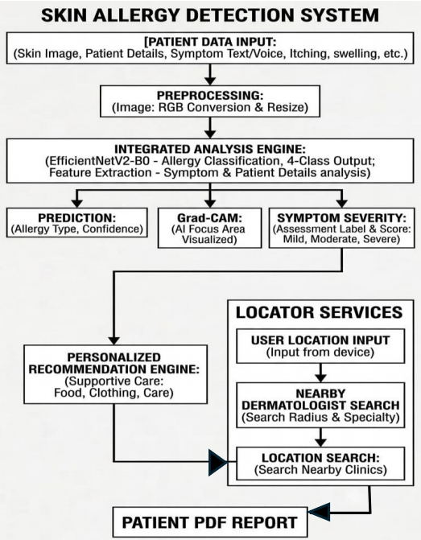

Fig.3.1.Integrated Architecture of Skin Allergy Detection and Personalized Healthcare Recommendation System

3.3 DESCRIPTION OF MODULES

The proposed system consists of several modules that work together to provide skin condition detection and personalized healthcare support. Each module performs a specific function, while all modules are connected to form a complete workflow.

1. Patient Data Input Module
This module collects basic patient details along with the skin image and symptom information. Symptoms can be provided through text or voice input.

2. Image Preprocessing Module
The uploaded skin image is processed before classification. The image is converted into RGB format and resized to 224 × 224 pixels to match the input requirements of the EfficientNetV2-B0 model.

3. Skin Condition Detection Module
This module uses the EfficientNetV2-B0 deep learning model with Transfer Learning to classify the uploaded image into four predefined conditions: Contact Dermatitis, Eczema, Psoriasis, and Urticaria.

4. Grad-CAM Visualization Module
The Grad-CAM module provides a visual explanation of the model prediction by highlighting the important regions of the input skin image that influenced the classification.

5. Symptom Severity Assessment Module
This module analyses the symptoms provided by the user, including itching, redness or irritation, swelling, affected area, pain or discomfort, and open skin, blistering, or oozing. Based on these indicators, the system provides a severity assessment.

6. Personalized Recommendation Module
This module provides general supportive recommendations related to food, clothing, and skin care based on the predicted condition and available assessment information.

7. Bilingual and Voice Interaction Module
The system supports English and Tamil interaction and provides voice-based symptom input to improve accessibility and ease of use.

8. Patient Report Generation Module
This module generates a PDF report containing relevant patient information, prediction results, symptom assessment, and recommendations for maintaining a record of the preliminary assessment.

9. Dermatologist Assistance Module
This module helps users search for nearby dermatologists or clinics using location-based information, supporting users in seeking professional consultation when required.
These modules are integrated into a single workflow, starting from patient input and image preprocessing and continuing through prediction, explanation, symptom assessment, recommendations, dermatologist assistance, and report generation.

3.4 DATA COLLECTION AND DATA PREPROCESSING

The dataset used in the proposed system consists of skin images belonging to four predefined conditions: Contact Dermatitis, Eczema, Psoriasis, and Urticaria. The images are collected and organized into separate class folders so that the deep learning model can learn the visual characteristics of each condition. The dataset is prepared to support the training, validation, and testing stages of the proposed system.

Before training the model, the collected images undergo a preprocessing stage to ensure that they are suitable for deep learning analysis. Each input image is converted into RGB format and resized to 224 × 224 pixels, which is the required input size used by the EfficientNetV2-B0 model. This process ensures that images with different dimensions are converted into a consistent format.

The preprocessing stage also helps maintain uniformity among the input images and prepares them for feature extraction. The processed images are then organized according to their respective classes and provided to the model during training. The four-class structure allows the model to learn the differences in visual patterns between the selected skin conditions.

After preprocessing, the prepared dataset is used for Transfer Learning with EfficientNetV2-B0. The model extracts relevant visual features from the skin images and learns to classify them into the four predefined classes. The trained model is then saved and used during application execution to analyse newly uploaded skin images and generate the corresponding prediction.

3.5 SKIN CONDITION DETECTION MODEL

The proposed system uses EfficientNetV2-B0 with Transfer Learning as the main deep learning model for skin condition detection. The model is designed to analyse skin images and classify them into four predefined conditions: Contact Dermatitis, Eczema, Psoriasis, and Urticaria. The use of a pre-trained model helps the system learn useful visual features from skin images and reduces the need to train the complete network from the beginning.

The input image is first prepared during the preprocessing stage. Each image is converted into RGB format and resized to 224 × 224 pixels before being given to the model. This ensures that all images follow a consistent input format. The processed image is then passed through the EfficientNetV2-B0 network for feature extraction and classification.

The model uses Transfer Learning to adapt the pre-trained network to the selected skin image dataset. During training, the model learns visual patterns associated with the four skin conditions. The final classification layer produces four output values corresponding to the four classes. The class with the highest output value is selected as the predicted condition.
The prediction process is integrated with the application so that users can upload a new skin image and obtain the corresponding preliminary classification. The system can also provide confidence information along with the predicted class. This allows the prediction result to be presented in a more informative manner.

The model is further supported by the Grad-CAM visualization module. Grad-CAM highlights the important regions of the input image that contributed to the model's prediction. This provides a visual explanation instead of displaying only the classification result and helps users understand which parts of the image influenced the prediction.

The trained model is saved and integrated into the Streamlit application. During application execution, the uploaded image is preprocessed and passed to the trained EfficientNetV2-B0 model. The prediction, visual explanation, and other assessment information are then displayed through the application. Thus, the EfficientNetV2-B0 model forms the main classification component of the proposed skin condition detection system.

Parameter | Configuration
Model | EfficientNetV2-B0
Learning Approach | Transfer Learning
Input Size | 224 × 224 pixels
Image Format | RGB
Number of Classes | 4
Classification Output | Predicted skin condition
Explanation Method | Grad-CAM

Table 3.5. Model Configuration

3.6 PROPOSED METHODOLOGY

The proposed methodology combines deep learning-based image classification, visual explanation, symptom assessment, and personalized supportive recommendations into a single workflow. The process begins when the user provides a skin image along with basic patient details and symptom information. The uploaded image is preprocessed into the required format before being given to the trained EfficientNetV2-B0 model.

The EfficientNetV2-B0 model with Transfer Learning analyses the processed image and classifies it into one of the four predefined skin conditions: Contact Dermatitis, Eczema, Psoriasis, and Urticaria. The prediction result is then supported using Grad-CAM, which highlights the important regions of the image that influenced the model's prediction. This provides a visual explanation of the classification result.

Along with image analysis, the system collects symptom information such as itching, redness or irritation, swelling, affected area, pain or discomfort, and open skin, blistering, or oozing. These symptoms are processed using a rule-based approach to provide a preliminary severity assessment. The predicted condition and symptom information are then used to generate general recommendations related to food, clothing, and supportive skin care.

The proposed methodology also integrates English and Tamil interaction, voice-based symptom input, patient report generation, and nearby dermatologist assistance. The final results are presented through a Streamlit-based interface, and the relevant information can be included in a PDF report. The complete methodology follows the workflow of input → preprocessing → prediction → explanation → symptom assessment → recommendation → report and dermatologist assistance, providing an integrated preliminary skin assessment system.

  - SUMMARY

This chapter presented the methodology used for developing the proposed AI-Based Skin Allergy Detection and Personalized Healthcare Recommendation System. The system requirements, architecture, modules, data preprocessing, and EfficientNetV2-B0-based skin condition detection model were discussed.

The proposed system combines image classification, Grad-CAM visualization, symptom assessment, and personalized supportive recommendations. Additional features such as bilingual interaction, voice-based symptom input, report generation, and dermatologist assistance are included to improve the usefulness and accessibility of the system.

Overall, the methodology provides a structured workflow from patient input and image preprocessing to skin condition prediction, visual explanation, symptom assessment, recommendations, and healthcare assistance. The system is designed as a preliminary screening and educational prototype to support users in understanding their skin condition.

CHAPTER 4
- SYSTEM IMPLEMENTATION:

GENERAL

The implementation of the proposed system focuses on developing a user-friendly application for skin condition detection and personalized healthcare support. The system integrates the trained EfficientNetV2-B0 model with the different modules discussed in the previous chapter.
The application is developed using Python, TensorFlow/Keras, Streamlit, NumPy, Pandas, and Pillow. Additional components are used for Grad-CAM visualization, symptom assessment, bilingual interaction, report generation, and dermatologist assistance.

The implementation follows a simple workflow in which the user provides the required information and uploads a skin image. The image is preprocessed and passed to the trained model for classification into one of the four predefined skin conditions. The prediction is then combined with symptom information to provide further supportive guidance.

The system also provides food, clothing, and supportive skin-care recommendations based on the available assessment information. The results are displayed through the Streamlit interface, and the relevant details can be included in a PDF patient report. The application is intended to provide preliminary information and support users in seeking professional medical advice when required.

  - SYSTEM WORKFLOW

The proposed system follows a systematic workflow for skin condition detection and personalized healthcare support. The process begins with the user providing basic patient details, symptom information, and a skin image. The uploaded image is then preprocessed by converting it into RGB format and resizing it to 224 × 224 pixels.

After preprocessing, the image is given to the EfficientNetV2-B0 model for classification. The model analyses the image and predicts one of the four predefined conditions: Contact Dermatitis, Eczema, Psoriasis, and Urticaria. The system also uses Grad-CAM to highlight important regions of the image that contributed to the prediction.

The symptom information provided by the user is analysed using the rule-based symptom assessment module. The system considers indicators such as itching, redness or irritation, swelling, affected area, pain or discomfort, and open skin, blistering, or oozing to provide a preliminary severity assessment.

Finally, the prediction and symptom assessment are used to provide food, clothing, and supportive skin-care recommendations. The system can also generate a PDF patient report and assist the user in finding nearby dermatologists or clinics. This workflow provides an integrated process from patient input to prediction, explanation, assessment, recommendations, and healthcare assistance.

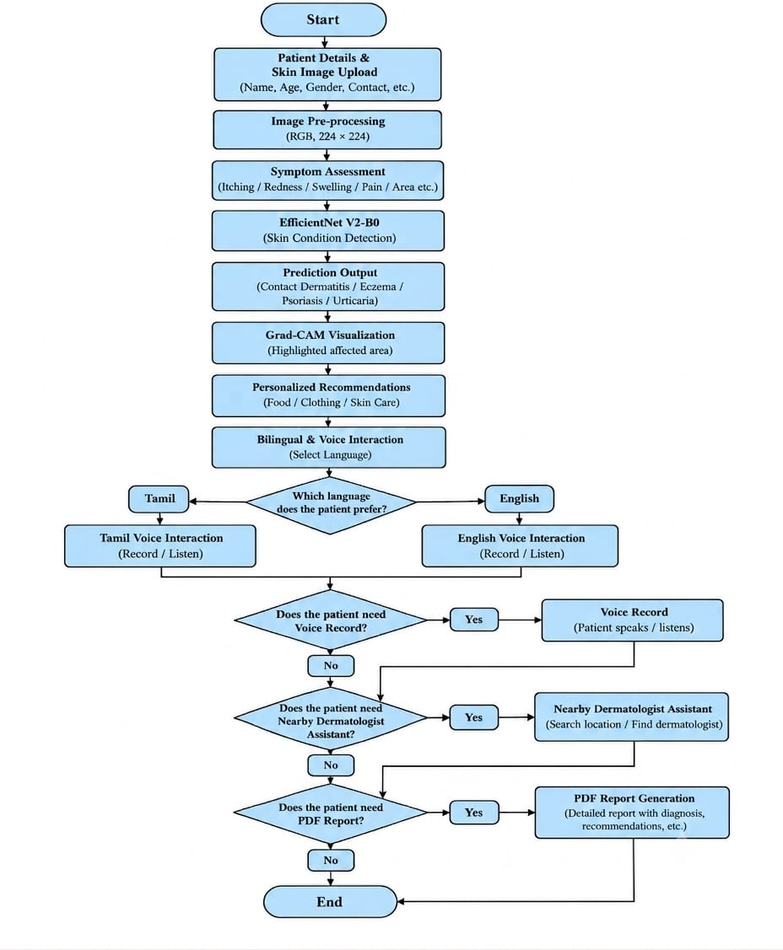

Fig.4.1 System Workflow Diagram

  - OVERVIEW OF THE PLATFORM

The proposed platform is a web-based application developed to provide preliminary skin condition detection and personalized healthcare support. The platform provides a simple interface where users can enter basic details, upload a skin image, and provide information about their symptoms.

The uploaded image is processed and analysed using the trained EfficientNetV2-B0 model. The platform displays the predicted skin condition along with Grad-CAM visualization to provide a visual explanation of the prediction. The symptom assessment module also analyses the information provided by the user.

Based on the assessment, the platform provides general food, clothing, and supportive skin-care recommendations. It also supports English and Tamil interaction, voice-based symptom input, PDF report generation, and nearby dermatologist assistance.
The complete platform is implemented using Python, TensorFlow/Keras, and Streamlit. All the modules are integrated into a single application to provide a simple workflow from image upload and prediction to recommendations and healthcare assistance.

The platform is designed to provide the required functions through a single integrated interface, reducing the need for users to use separate applications for image analysis, symptom assessment, recommendations, and report preparation. This integrated approach makes the system easier to use and provides a structured workflow for obtaining preliminary skin condition information and appropriate supportive guidance.

  - MODULE IMPLEMENTATION

The proposed system is implemented as a collection of interconnected modules, where each module performs a specific function in the skin condition assessment process. The modules are integrated through the Streamlit application so that the user can complete the assessment through a single interface.

4.4.1 Patient Input and Image Upload
This module collects the required patient details, skin image, and symptom information. The user can upload a skin image through the application and provide the symptoms experienced. The collected information is used by the subsequent modules for image analysis and symptom assessment
.
4.4.2 Image Preprocessing and Detection
The uploaded image is converted into RGB format and resized to 224 × 224 pixels before being passed to the trained EfficientNetV2-B0 model. The model analyses the image and classifies it into one of the four predefined conditions: Contact Dermatitis, Eczema, Psoriasis, and Urticaria.

4.4.3 Explanation and Symptom Assessment
The Grad-CAM module provides a visual explanation by highlighting important regions of the input image. At the same time, the symptom assessment module analyses the symptoms entered by the user and provides a preliminary severity assessment based on the defined indicators.

4.4.4 Recommendation and Support Features
The system provides general food, clothing, and supportive skin-care recommendations based on the available assessment information. Additional features such as English and Tamil interaction, voice-based symptom input, PDF report generation, and nearby dermatologist assistance are also integrated into the application.
Overall, these modules work together to provide a structured workflow from patient input and image analysis to prediction, explanation, symptom assessment, recommendations, and healthcare assistance.

  - SUMMARY

This chapter described the implementation of the proposed AI-Based Skin Allergy Detection and Personalized Healthcare Recommendation System. The platform overview, system workflow, and implementation of the major modules were discussed.
The system integrates image preprocessing, EfficientNetV2-B0-based skin condition detection, Grad-CAM visualization, symptom assessment, and personalized supportive recommendations. Features such as bilingual interaction, voice-based symptom input, PDF report generation, and dermatologist assistance are also included.
Overall, the implementation provides a structured workflow from patient input and image upload to prediction, explanation, recommendations, and healthcare assistance through a Streamlit-based application. The next chapter focuses on the experimental analysis and evaluation of the developed system.

CHAPTER 5

CHAPTER 5 – EXPERIMENTAL ANALYSIS

5.1 EXPERIMENTAL SETUP

The experimental setup is used to evaluate the performance and functionality of the proposed AI-Based Skin Allergy Detection and Personalized Healthcare Recommendation System. The trained EfficientNetV2-B0 model is tested using skin images belonging to the four predefined conditions: Contact Dermatitis, Eczema, Psoriasis, and Urticaria.

The system is implemented using Python, TensorFlow/Keras, and Streamlit. The input images are processed at a size of 224 × 224 pixels and provided to the trained model for classification. The system also uses Grad-CAM to visualize the important regions considered during prediction.

The experimental evaluation includes the model's classification results, prediction confidence, visual explanations, and the functionality of the supporting modules. The symptom assessment, personalized recommendations, PDF report generation, and dermatologist assistance are also checked to ensure that the complete application workflow operates properly.

The experimental setup helps to understand the effectiveness of the developed system and identify areas that can be improved in future versions.

5.1.1 Dataset Description and Characteristics

The dataset used in this project consists of skin images belonging to four predefined skin conditions: Contact Dermatitis, Eczema, Psoriasis, and Urticaria. The images are organized into separate classes according to their respective skin conditions, allowing the EfficientNetV2-B0 model to learn the visual characteristics associated with each class.

The dataset contains different skin images representing the appearance and visual patterns of the selected conditions. These images are used for developing and evaluating the skin condition classification model. The four-class structure enables the system to distinguish between Contact Dermatitis, Eczema, Psoriasis, and Urticaria.

Before being provided to the deep learning model, the images are checked and prepared into a consistent format. This helps maintain uniformity in the input data and supports effective training and evaluation of the EfficientNetV2-B0 model.

5.1.2 Data Preprocessing Techniques

The collected skin images may have different dimensions, formats, and image characteristics. Therefore, preprocessing is performed before providing the images to the EfficientNetV2-B0 model. The preprocessing step helps maintain a consistent input format and prepares the images for effective model processing.
Each skin image is converted into RGB format and resized to 224 × 224 pixels, which is the input size used by the EfficientNetV2-B0 model. This ensures that all images provided to the model have the same dimensions.The processed images are organized according to their respective classes: Contact Dermatitis, Eczema, Psoriasis, and Urticaria. This class-wise organization helps the model learn the visual characteristics associated with each skin condition.The preprocessing stage also ensures that the images are suitable for the training, validation, testing, and prediction stages. The prepared images are then provided to the EfficientNetV2-B0 model for feature extraction and skin condition classification.

5.1.3 Dataset Splitting Strategy

The prepared skin image dataset is divided into separate subsets for training, validation, and testing of the EfficientNetV2-B0 model. The training data is used to teach the model the visual characteristics of the four selected skin conditions.The validation data is used during the model development process to monitor the performance of the model on images that are not directly used for training. This helps in observing the learning behaviour of the model and identifying possible overfitting.
The test data is used to evaluate the trained model using unseen skin images. The test results provide an indication of how effectively the model can classify images that were not included during the training process.The images are maintained according to the four classes: Contact Dermatitis, Eczema, Psoriasis, and Urticaria. This separation supports proper evaluation of the classification performance of the proposed system.

Dataset | Purpose
Training Set | Used to train the EfficientNetV2-B0 model
Validation Set | Used to monitor model learning and performance during training
Test Set | Used to evaluate the model using unseen images

Table 5.1. Dataset Splitting Strategy

5.1.4 System Architecture

5.1 System Architecture of AI-Based Skin Allergy Detection and Personalized Healthcare Recommendation

5.1.5 Hardware Configuration

The proposed skin allergy detection system can be implemented using a standard computer or laptop with sufficient processing and memory capacity. The hardware is used for developing the deep learning model, processing skin images, and running the Streamlit application.

The system requires a multi-core processor and adequate RAM to perform image preprocessing and execute the trained EfficientNetV2-B0 model. Sufficient storage is also required to store the skin image dataset, trained model, application files, and generated patient reports.

A stable internet connection may be required for features such as nearby dermatologist or clinic assistance. The developed application can be executed on a standard computing system without requiring specialized hardware for normal prediction and application usage.

5.1.6 Software Environment

The proposed skin allergy detection system is developed using Python as the primary programming language. TensorFlow and Keras are used to implement the EfficientNetV2-B0 deep learning model and perform skin image classification. Pillow (PIL), NumPy, and Pandas are used for image handling and data processing.

Streamlit is used to develop the web-based application interface and integrate the different modules into a single platform. Grad-CAM is used to generate visual explanations for the model predictions, while SpeechRecognition supports voice-based symptom input. ReportLab is used to generate the patient PDF report.

The system also uses supporting components for symptom severity assessment, personalized recommendations, bilingual English and Tamil interaction, and nearby dermatologist assistance. These software components work together to provide the complete workflow from image upload and prediction to explanation, recommendations, and report generation.

5.1.7 Model Architecture and Design

The proposed system uses EfficientNetV2-B0 with Transfer Learning as the main deep learning model for skin condition classification. The model receives skin images as input after preprocessing, where the images are converted into RGB format and resized to 224 × 224 pixels.

The pre-trained EfficientNetV2-B0 network is used to extract important visual features from the input skin images. The classification layer is adapted to the four selected conditions: Contact Dermatitis, Eczema, Psoriasis, and Urticaria. The class with the highest prediction value is selected as the predicted skin condition.

The model output is integrated with the Grad-CAM module to provide a visual explanation of the prediction. The system also displays prediction confidence for individual uploaded images. This model architecture forms the main classification component of the proposed skin allergy detection system.
Overall, the model is designed to provide preliminary skin condition classification while working together with the symptom assessment and personalized recommendation modules in the application.

5.1.8 Training Strategy

The EfficientNetV2-B0 model is trained using the prepared skin image dataset containing four predefined classes: Contact Dermatitis, Eczema, Psoriasis, and Urticaria. Transfer Learning is used so that the pre-trained model can learn the visual characteristics of the selected skin conditions without training the complete network from the beginning.

During training, the prepared images are provided to the model in the required input format of 224 × 224 pixels. The model learns relevant visual patterns from the training images and adjusts its classification capability for the four selected classes. Validation data is used to monitor the model's performance during the training process.

After training, the model is evaluated using unseen test images to determine its ability to classify the selected skin conditions. The trained model is then saved and integrated into the Streamlit application for prediction of newly uploaded skin images.

The training strategy forms the foundation of the skin condition detection module, while Grad-CAM and the other supporting modules are used to provide explanation, symptom assessment, recommendations, and additional healthcare assistance.

5.2 PERFORMANCE EVALUATION

The performance evaluation of the proposed system focuses on the classification capability of the EfficientNetV2-B0 model and the functionality of the supporting modules. The evaluation considers the prediction results obtained for the four predefined skin conditions: Contact Dermatitis, Eczema, Psoriasis, and Urticaria.

The system displays prediction confidence for individual uploaded skin images and provides Grad-CAM visualizations to explain the model prediction. The symptom severity assessment and personalized recommendation modules are also considered as part of the overall application evaluation.

The performance evaluation helps to understand how effectively the developed system performs skin condition classification and provides the additional features integrated into the application. Further quantitative evaluation can be performed using the complete test dataset and the original model evaluation results.

5.2.1 Evaluation Metrics

The performance of the proposed skin condition detection model can be evaluated using standard classification metrics such as accuracy, precision, recall, and F1-score. These metrics help to measure how effectively the EfficientNetV2-B0 model classifies the four predefined skin conditions.
Accuracy represents the overall proportion of correctly classified images. Precision measures how accurately the model identifies images as belonging to a particular condition. Recall measures the ability of the model to correctly identify images belonging to a condition. F1-score provides a combined measure of precision and recall.

Prediction confidence is also displayed for individual uploaded images through the application. However, the confidence value of a single prediction should not be considered as the overall accuracy of the trained model. A complete evaluation requires results from the complete test dataset.

Skin Condition | PredictionConfidence
Urticaria | 90.00%
Psoriasis | 95.02%
Eczema | 93.91%
Contact Dermatitis | 91.13%

Table 5.2. Prediction Confidence

Evaluation Component | Purpose
Accuracy | Measures overall classification performance
Precision | Measures correctness of positive predictions
Recall | Measures ability to identify the condition
F1-Score | Combines precision and recall
Grad-CAM | Provides visual explanation
Prediction Confidence | Shows confidence for an individual prediction

Table 5.3. Evaluation Features

5.2.2 Performance Graphs

The performance of the proposed system can be represented using graphical results obtained from the skin condition prediction process. The graphs help to present the model outputs in a simple and understandable manner for the four supported conditions: Contact Dermatitis, Eczema, Psoriasis, and Urticaria.

The available experimental graph presents the prediction confidence obtained from sample skin image uploads. The system produced confidence values for each predicted condition, which can be used to compare the prediction results across the four sample inputs.

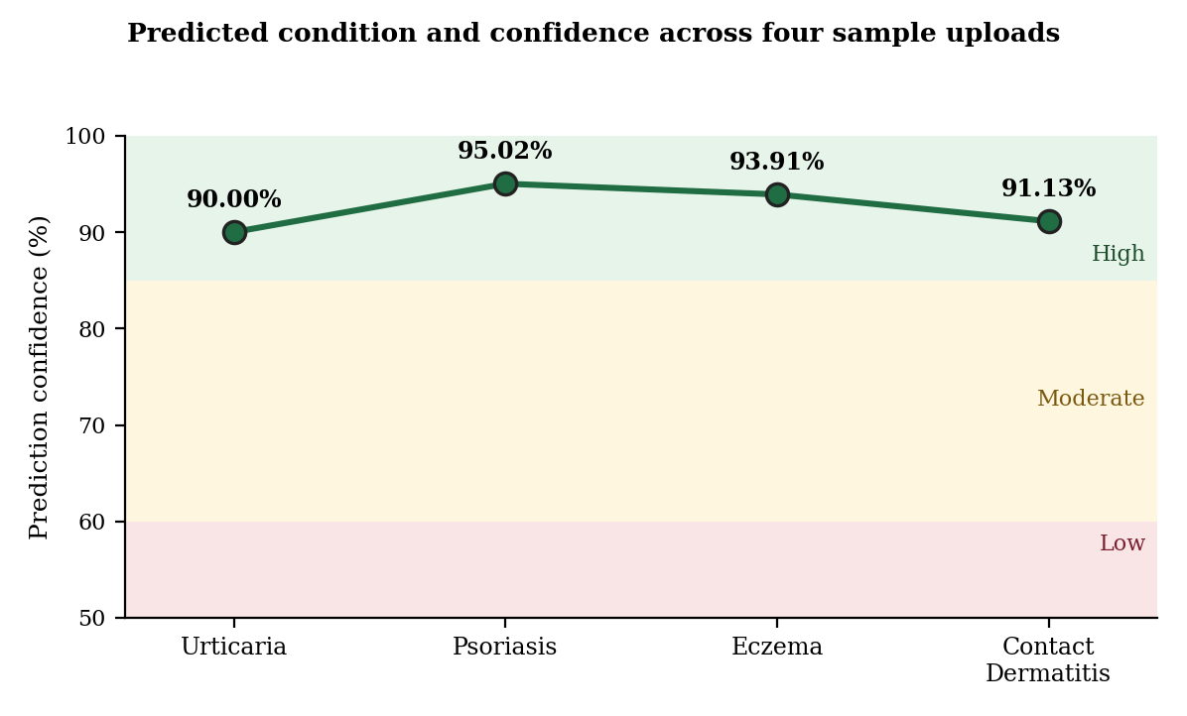

Fig. 5.2. Predicted Condition and Confidence Across Four Sample Uploads

The graph shows prediction confidence values of 90.00% for Urticaria, 95.02% for Psoriasis, 93.91% for Eczema, and 91.13% for Contact Dermatitis. Among the four sample predictions, Psoriasis produced the highest confidence value of 95.02%, while Urticaria produced the lowest value of 90.00%.

These values represent the confidence of individual sample predictions and should not be considered as the overall accuracy of the model. Training and validation graphs, confusion matrix, and class-wise evaluation graphs can be included when the corresponding original model evaluation results are available.

5.2.3 Detailed Performance Analysis

The performance of the proposed system is analysed based on the prediction results generated by the trained EfficientNetV2-B0 model. The model is designed to classify skin images into four predefined conditions: Contact Dermatitis, Eczema, Psoriasis, and Urticaria.

The application provides prediction confidence for each uploaded skin image. In the demonstrated sample results, the system produced confidence values of 95.02% for Psoriasis, 93.91% for Eczema, 91.13% for Contact Dermatitis, and 90.00% for Urticaria. These results show that the system generated confident predictions for the selected sample inputs.

However, these values represent the confidence of individual predictions and should not be treated as the overall model accuracy. Complete performance analysis using accuracy, precision, recall, F1-score, and confusion matrix requires the actual results obtained from the complete test dataset.

The analysis also considers the supporting features of the application, including Grad-CAM visualization, symptom severity assessment, personalized recommendations, voice input, dermatologist assistance, and patient report generation.

5.2.4 Explainability Evaluation

The proposed system uses Grad-CAM (Gradient-weighted Class Activation Mapping) to provide a visual explanation of the EfficientNetV2-B0 prediction. The technique highlights the important regions of the uploaded skin image that contributed to the predicted skin condition.
The application displays the original skin image together with the Grad-CAM visualization. The highlighted regions help users understand which areas of the image received greater attention from the deep learning model during classification.

This explainability feature makes the proposed system more informative than a basic image classification system that provides only the predicted condition and confidence value. It also provides an additional way to examine the model's prediction during preliminary skin condition assessment.

Overall, Grad-CAM improves the interpretability of the proposed system by providing a visual representation of the regions that influenced the model's prediction.

5.3 COMPARISON WITH EXISTING WORK

Existing skin condition detection systems mainly focus on analysing skin images and predicting a particular skin condition using Artificial Intelligence and Deep Learning techniques. Many systems provide the classification result without integrating additional supportive features for the user.
The proposed system uses EfficientNetV2-B0 with Transfer Learning to classify four predefined skin conditions: Contact Dermatitis, Eczema, Psoriasis, and Urticaria. In addition to classification, Grad-CAM is used to provide a visual explanation of the prediction.

The proposed system also integrates a rule-based symptom severity assessment and personalized supportive recommendations related to food, clothing, and skin care. These features provide additional information along with the image-based prediction.

Furthermore, the system includes English and Tamil interaction, voice-based symptom input, PDF patient report generation, and nearby dermatologist assistance. Therefore, the proposed system provides an integrated workflow that combines skin image classification, explanation, symptom assessment, and supportive healthcare features in a single application.

The proposed system also provides a complete workflow from patient input to preliminary assessment and supportive healthcare guidance. By combining image classification, visual explanation, symptom assessment, recommendations, and additional accessibility features in one platform, the system reduces the need to use separate tools for different stages of the assessment process. This integrated approach makes the application more convenient for users while maintaining its role as a preliminary screening and educational support system.

Feature | Existing Systems | Proposed System
Skin Image Classification | Available | Available
Deep Learning | Available in many systems | EfficientNetV2-B0
Four Selected Conditions | May be limited | Available
Transfer Learning | Used in some systems | Available
Grad-CAM Explanation | May be limited | Available
Symptom Assessment | May be limited | Available
Food Recommendation | May be limited | Available
Clothing Recommendation | May be limited | Available
Supportive Skin Care | May be limited | Available
Voice-Based Input | May be limited | Available
English/Tamil Interaction | May be limited | Available
PDF Patient Report | May be limited | Available
Dermatologist Assistance | May be limited | Available

Table 5.4. Comparison of Existing System and Proposed System

5.4 RESULTS AND DISCUSSIONS

The experimental results of the proposed AI-Based Skin Allergy Detection and Personalized Healthcare Recommendation System are discussed based on the outputs generated by the developed application. The evaluation focuses on the EfficientNetV2-B0 classification model and the supporting features integrated into the system.

The system successfully processes uploaded skin images and provides a predicted skin condition along with prediction confidence. Grad-CAM visualization, symptom severity assessment, personalized recommendations, and other supporting features are also provided through the application.

The results demonstrate the working capability of the developed system for preliminary skin condition assessment. However, the prediction confidence of individual images should not be considered as the overall classification accuracy of the model. Further evaluation using complete test data and dermatologist-reviewed cases is required for stronger validation.

5.4.1 Experimental Result

The experimental results show that the developed system can process uploaded skin images and provide a preliminary classification using the trained EfficientNetV2-B0 model. The application displays the uploaded image, predicted skin condition, and prediction confidence through the Streamlit interface.
In the demonstrated sample results, the system produced prediction confidence values of 90.00% for Urticaria, 95.02% for Psoriasis, 93.91% for Eczema, and 91.13% for Contact Dermatitis. Among these sample predictions, Psoriasis produced the highest confidence value of 95.02%.
The system also successfully provides Grad-CAM visualization for explaining the prediction and includes symptom severity assessment, personalized recommendations, voice-based symptom input, nearby dermatologist assistance, and patient report generation.
These results demonstrate the functional performance of the developed application. However, the sample prediction confidence values represent individual outputs and should not be interpreted as the overall accuracy of the trained model.

5.4.2 Interpretation of Visual Results

The visual results provide additional information about the prediction generated by the proposed system. The uploaded skin image is displayed along with the predicted condition and its confidence value, allowing the user to understand the output provided by the EfficientNetV2-B0 model.

The Grad-CAM visualization highlights important regions of the skin image that contributed to the model's prediction. This provides an explanation-oriented output and helps the user understand the areas considered by the model during classification.

The symptom assessment interface also provides information about the user's reported symptoms, including itching, redness or irritation, swelling, affected skin area, pain or discomfort, and open skin, blistering, or oozing. These visual and assessment results work together to provide a more informative preliminary skin condition assessment.

5.4.3 Classification Performance Analysis

The classification performance of the proposed system is evaluated based on the ability of the EfficientNetV2-B0 model to identify the four predefined skin conditions: Contact Dermatitis, Eczema, Psoriasis, and Urticaria. The model analyses the uploaded skin image and selects the condition corresponding to the highest prediction value.

The application also displays a confidence value for each individual prediction. The sample results show confidence values above 90% for the four demonstrated skin conditions. These values indicate the confidence associated with the respective sample predictions.

However, individual prediction confidence cannot be considered as the overall classification accuracy of the model. A complete classification performance analysis requires the actual test dataset results using metrics such as accuracy, precision, recall, F1-score, and confusion matrix.

5.4.4 Training and Validation Performance

The training and validation performance of the EfficientNetV2-B0 model can be analysed using training and validation accuracy and loss graphs. These graphs help to understand how the model learns from the training images and how its performance changes when evaluated using validation images.

Training accuracy indicates the classification performance on the training data, while validation accuracy indicates the performance on the validation data. Similarly, training and validation loss values help to observe the learning behaviour of the model during training.

A comparison between training and validation results can also help identify possible overfitting or underfitting. However, the original training history values and graphs are not currently available in the provided results. Therefore, exact numerical training and validation values are not reported in this section.

5.4.5 Explainability Analysis

The explainability of the proposed system is evaluated using the Grad-CAM technique integrated with the EfficientNetV2-B0 model. Grad-CAM generates a visual representation of the important regions of the uploaded skin image that influenced the model's prediction.

The system displays the original skin image along with the corresponding Grad-CAM visualization. The highlighted regions provide an indication of the areas that received greater attention from the model during the classification process.

This explainability feature provides additional information beyond the predicted condition and confidence value. It makes the prediction easier to interpret and supports a better understanding of the model's decision during preliminary skin condition assessment.

5.4.6 Real-Time Performance Evaluation

The developed Streamlit application provides the prediction result after the user uploads a skin image. The uploaded image is processed and passed to the trained EfficientNetV2-B0 model, after which the predicted skin condition and confidence value are displayed through the application interface.

The system also provides the supporting outputs within the same workflow, including Grad-CAM visualization and symptom severity assessment. Based on the assessment, personalized recommendations and other healthcare support features are provided to the user.

The integrated workflow allows the user to obtain the required preliminary skin condition information through a single application. The system can also generate a patient PDF report and provide nearby dermatologist assistance when required.

Overall, the real-time evaluation demonstrates that the developed application can integrate image prediction and supporting features into a single workflow for preliminary skin condition assessment.

5.4.7 Discussion of Results

The overall results demonstrate that the proposed system successfully integrates deep learning-based skin condition classification with additional healthcare support features. The EfficientNetV2-B0 model provides the main classification functionality, while Grad-CAM provides a visual explanation of the prediction.

The symptom severity assessment module provides structured information based on the symptoms entered by the user. The personalized recommendation module provides general supportive guidance related to food, clothing, and skin care. Voice input, bilingual interaction, dermatologist assistance, and PDF report generation further improve the functionality of the application.

The sample prediction results show that the developed application can generate confident predictions for the four supported skin conditions. However, these individual confidence values should not be interpreted as clinical accuracy or overall model accuracy.

Overall, the developed system demonstrates the feasibility of combining skin image analysis, explainability, symptom assessment, and supportive recommendations in a single application. Further validation using larger and more diverse datasets and dermatologist-reviewed cases is required before considering clinical

5.4.8 Strengths of the Proposed System

The proposed system combines skin image classification, Grad-CAM explainability, symptom severity assessment, and personalized supportive recommendations within a single application. This provides more functionality than a basic skin image classification system.

The use of EfficientNetV2-B0 with Transfer Learning supports the classification of the four selected skin conditions. Grad-CAM provides a visual explanation of the prediction, helping users understand the important regions considered by the model.

The system also includes English and Tamil interaction, voice-based symptom input, PDF report generation, and nearby dermatologist assistance. These features improve accessibility and provide additional support during the preliminary assessment process.
Overall, the integration of multiple features into a single Streamlit-based platform is one of the main strengths of the proposed system.

5.4.9 Challenges and Limitations

The performance of the proposed system depends on the quality, size, and diversity of the skin image dataset used for model development. Differences in skin tone, image quality, lighting conditions, and image-capturing devices may affect the prediction results.
The system is currently limited to four predefined skin conditions: Contact Dermatitis, Eczema, Psoriasis, and Urticaria. Therefore, it cannot be used to identify skin conditions outside these selected classes.

The system is intended for preliminary screening and educational support and should not be considered a clinical diagnostic system. The prediction confidence shown for an individual image does not represent clinical accuracy.
Further validation using larger and more diverse datasets, dermatologist-reviewed cases, and different real-world image conditions is required to improve the reliability of the proposed system.

5.4.9 Future Improvements

Future improvements can focus on developing the proposed system using larger and more diverse skin image datasets. Additional dermatologist-reviewed cases can be included to improve the evaluation and reliability of the skin condition classification model.

The system can also be extended to support more skin conditions beyond the four classes currently included. Improvements can be made in image-quality assessment and in refining the personalized supportive recommendations based on user-provided information.
Further validation can be performed using images with different skin tones, lighting conditions, and imaging devices. This can help evaluate the system under different real-world conditions and improve its reliability.

Future versions can also improve the existing bilingual and voice-based interaction, report generation, and dermatologist assistance features. These improvements can make the system more useful while maintaining its role as a preliminary screening and supportive healthcare application.

5.6.SUMMARY

This chapter presented the experimental setup, performance evaluation, comparison with existing work, and results and discussions of the proposed AI-Based Skin Allergy Detection and Personalized Healthcare Recommendation System.The evaluation focused on the EfficientNetV2-B0 classification model, prediction confidence, Grad-CAM visualization, symptom severity assessment, and supporting application features. The developed application successfully provided skin condition predictions along with personalized recommendations, voice-based input, dermatologist assistance, and patient report generation.Overall, the results demonstrate that the proposed system provides an integrated platform for preliminary skin condition assessment and supportive healthcare information. However, further evaluation using complete test results, larger and more diverse datasets, and dermatologist-reviewed cases is required to establish stronger reliability and performance.

CHAPTER 6

- CONCLUSION AND FUTURE WORK

6.1 CONCLUSION

The proposed AI-Based Skin Allergy Detection and Personalized Healthcare Recommendation System Using Deep Learning was developed to provide preliminary skin condition assessment through an integrated application. The system uses EfficientNetV2-B0 with Transfer Learning to analyse uploaded skin images and classify them into four predefined conditions: Contact Dermatitis, Eczema, Psoriasis, and Urticaria.

The system combines image classification with Grad-CAM-based visual explanation and rule-based symptom severity assessment. The Grad-CAM module provides visual information about the important regions considered during prediction, while the symptom assessment module considers user-provided symptoms to provide additional preliminary information.

In addition to prediction, the system provides personalized supportive recommendations related to food, clothing, and skin care. Features such as English and Tamil interaction, voice-based symptom input, patient PDF report generation, and nearby dermatologist assistance are also integrated into the application. These features provide a complete workflow from patient input to preliminary assessment and supportive healthcare guidance.

The developed system demonstrates the usefulness of combining deep learning, explainable AI, symptom assessment, and supportive recommendations in a single platform. However, the system is intended as a preliminary screening and educational prototype and should not be considered a replacement for professional medical diagnosis or consultation.

  - LIMITATION OF CURRENT WORK

The current system has certain limitations that can affect its performance and practical use. The model is trained to identify only four predefined skin conditions: Contact Dermatitis, Eczema, Psoriasis, and Urticaria. Therefore, the system cannot provide classification for skin conditions outside these selected classes.

The performance of the model may also depend on the quality, size, and diversity of the available skin image dataset. Differences in skin tone, lighting conditions, image quality, and image-capturing devices may affect the prediction results.

Another limitation is that the system has not been established as a clinical diagnostic tool. The prediction confidence displayed for an individual image should not be interpreted as overall model accuracy or medical certainty. Professional dermatologist validation is required to assess the system under real-world clinical conditions.

The personalized recommendations provided by the system are general supportive recommendations and should not be considered as individualized medical treatment. Further validation and improvement are required before the system can be considered for wider healthcare applications.

  - FUTURE ENHANCEMENT

Future enhancement of the proposed system can focus on improving the deep learning model using larger and more diverse skin image datasets. Additional dermatologist-reviewed cases can be included to provide stronger validation of the classification results.

The system can also be extended to support a larger number of skin conditions beyond the four currently supported classes. Improvements in image-quality assessment can help identify unsuitable or unclear images before they are processed by the classification model.

Further development can focus on improving the personalized recommendation module by refining the food, clothing, and supportive skin-care information based on the available assessment. The system can also be evaluated using images captured under different lighting conditions, skin tones, and imaging devices.

The existing bilingual interaction, voice-based symptom input, PDF report generation, and dermatologist assistance can also be improved to provide a more convenient user experience. These enhancements can increase the usefulness of the system while maintaining appropriate limitations and professional medical guidance.

6.4 SUMMARY

This chapter presented the conclusion, limitations, and future enhancements of the proposed AI-Based Skin Allergy Detection and Personalized Healthcare Recommendation System. The system integrates EfficientNetV2-B0-based skin condition classification, Grad-CAM visualization, symptom severity assessment, and personalized supportive recommendations.

The application also provides additional features such as English and Tamil interaction, voice-based symptom input, patient report generation, and nearby dermatologist assistance. These components provide an integrated platform for preliminary skin condition assessment and supportive healthcare information.

The current limitations and possible future improvements were also discussed. Overall, the proposed system demonstrates the potential of Deep Learning and explainable AI for supporting preliminary skin condition assessment, while further dataset expansion, dermatologist validation, and real-world evaluation are required for future development.

CHAPTER 7

- REFERENCES

[1] Abdul Rafay and Waqar Hussain, “EfficientSkinDis: An EfficientNet-based classification model for a large manually curated dataset of 31 skin diseases,” Biomedical Signal Processing and Control, vol. 85, 104869, 2023.

[2] Sudarshan Nath, Suparna Das Gupta, and Soumyabrata Saha, “Deep learning-based common skin disease image classification,” Journal of Intelligent & Fuzzy Systems, vol. 44, no. 5, 2023.

[3] Lulwah AlSuwaidan, “Deep Learning Based Classification of Dermatological Disorders,” Clinical Medicine Insights: Case Reports, 2023.

[4] Qingxu Zou, Jinyong Cheng, and Zhenlu Liang, “Automatic Diagnosis of Melanoma Based on EfficientNet and Patch Strategy,” International Journal of Computational Intelligence Systems, vol. 16, article 87, 2023.

[5] “Enhancing Dermatological Diagnostics with EfficientNet: A Deep Learning Approach,” Bioengineering, vol. 11, no. 8, 810, 2024.

[6] Jayanth Mohan, Arrun Sivasubramanian, V. Sowmya, and Ravi Vinayakumar, “Enhancing Skin Disease Classification Leveraging Transformer-based Deep Learning Architectures and Explainable AI,” 2024.

[7] “EffSVMNet: An efficient hybrid neural network for improved skin disease classification,” Smart Health, vol. 34, 100520, 2024.

[8] “EffiCAT: A synergistic approach to skin disease classification through multi-dataset fusion and attention mechanisms,” Biomedical Signal Processing and Control, vol. 100, 107141, 2025.

[9] Madallah Alruwaili and Mahmood Mohamed, “An Integrated Deep Learning Model with EfficientNet and ResNet for Accurate Multi-Class Skin Disease Classification,” Diagnostics, vol. 15, no. 5, 551, 2025.

[10] “An explainable hybrid deep learning framework for precise skin lesion segmentation and multi-class classification,” Frontiers in Medicine, 2025.

[11] “Attention-guided multimodal skin disease classification using discounted Dempster–Shafer fusion and EfficientNet,” Informatics in Medicine Unlocked, vol. 58, 101699, 2025.

[12] “A compact version of EfficientNet for skin disease diagnosis application,” Neurocomputing, vol. 620, 129166, 2025.

[13] “A novel Skin lesion prediction and classification technique: ViT-GradCAM,” 2024.
[14] “Visual Bias and Interpretability in Deep Learning for Dermatological Image Analysis,” 2025.

[15] “Toward Accessible Dermatology: Skin Lesion Classification Using Deep Learning Models on Mobile-Acquired Images,” 2025.

[16] “Comparative performance of deep learning models and non-dermatologists in diagnosing psoriasis, dermatophytosis, and eczema,” Scientific Reports, 2025.

[17] “A Transfer Learning System for Skin Disease Classification Using EfficientNet-B5 with Grad-CAM Explainability,” Applied Sciences, vol. 16, no. 6, 3083, 2026.

[18] “EfficientNet based Deep Learning Framework for Significant Classification and Early Detection of Skin Diseases,” 2026 7th International Conference on Intelligent Communication Technologies and Virtual Mobile Networks, 2026.

[19] “AI-driven dermatological diagnostics: A systematic review of machine and deep learning methods for skin disease classification,” 2026.

CHAPTER 8

8.SOURCE CODE:

import streamlit as st
import numpy as np
import tensorflow as tf
import speech_recognition as sr
import requests

from PIL import Image
from io import BytesIO
from datetime import datetime
from geopy.distance import geodesic
from streamlit_geolocation import streamlit_geolocation

from severity_engine import calculate_severity
from automatic_recommendation_engine import get_automatic_recommendations

from reportlab.lib.pagesizes import A4
from reportlab.platypus import (
SimpleDocTemplate, Paragraph, Spacer,
Image as ReportLabImage
)
from reportlab.lib.styles import getSampleStyleSheet
from reportlab.lib.units import inch

CONFIGURATION

st.set_page_config(
page_title="DermaAI",
page_icon="🩺",
layout="wide",
initial_sidebar_state="expanded"
)

MODEL_PATH = "skin_allergy_efficientnetv2b0.keras"
IMG_SIZE = (224, 224)

CLASS_NAMES = [
"Contact_dermatitis",
"Eczema",
"Psoriasis",
"Urticaria"
]

LANGUAGE

if "language" not in st.session_state:
st.session_state.language = "English"

"தமிழ்"
else "Name",

"age":
"வயது" if language == "தமிழ்"
else "Age",

"gender":
"பாலினம்" if language == "தமிழ்"
else "Gender",

"uploaded_image":
"confidence":
"கணிப்பு நம்பகத்தன்மை" if language == "தமிழ்"
else "Prediction Confidence",

"low_confidence":
"குறைந்த நம்பகத்தன்மை கொண்ட கணிப்பு" if language == "தமிழ்"
else "Low-confidence prediction",

"original_image":
"அசல் படம்" if language == "தமிழ்"
else "Original Image",

"ai_focus":
"AI கவனம் செலுத்தும் பகுதி" if language == "தமிழ்"
else "AI Focus Area",

"download_report":
"📄 நோயாளி அறிக்கையை பதிவிறக்கவும்"
if language == "தமிழ்"
else "📄 Download Patient Report"
}

GRAD-CAM

def make_gradcam_heatmap(
img_array,
model,
pred_index=None
):

base_model = model.get_layer("efficientnetv2-b0")
gap_layer = model.get_layer(
"global_average_pooling2d"
)
dense_layer = model.get_layer("dense")

with tf.GradientTape() as tape:

feature_maps = base_model(
img_array,
training=False
)

if pred_index is None:
pred_index = tf.argmax(predictions[0])

class_score = predictions[
0, pred_index
]

grads = tape.gradient(
class_score,
feature_maps
)

if grads is None:
raise ValueError(
"Gradients could not be calculated."
)

pooled_grads = tf.reduce_mean(
grads,
axis=(1, 2)
)

return heatmap.numpy()

def create_gradcam_image(
original_image,
heatmap
):

import cv2

if isinstance(
original_image,
Image.Image
):

)

story.append(Spacer(1, 20))

story.append(
.prediction-name {
font-size: 28px;
font-weight: 800;
}

.care-card {
"Female",
"Other",
"Prefer not to say"
]
)

with col2:

patient_phone = st.text_input(
"Contact Number"
)

previous_allergy = st.selectbox(
"Previous Skin Allergy",
[
"Select",
"Yes",
"No",
"Not sure"
]
)

swelling_level = st.select_slider(
with tab2:

for item in clothing:

text = (
item.get(
"recommendation",
item.get(
"text",
str(item)
)
)
if isinstance(item, dict)
else str(item)
)

st.markdown(
f"""
<div class="care-card">
👕 {text}
</div>
""",
unsafe_allow_html=True
)

with tab3:

for item in care:

if isinstance(item, dict):

title = item.get(
"care_option",
item.get(
"title",
"Supportive Care"
)
)

st.write(
f"📏 {clinic['distance']:.2f} km"
)

st.download_button(
label=TEXT["download_report"],
data=report_file,
file_name=(
"Patient_Skin_Allergy_Report.pdf"
),
mime="application/pdf"
)

FOOTER

st.markdown("---")

st.caption(
"DermaAI — AI-based skin condition "
"analysis for informational purposes."
)

OUTPUT

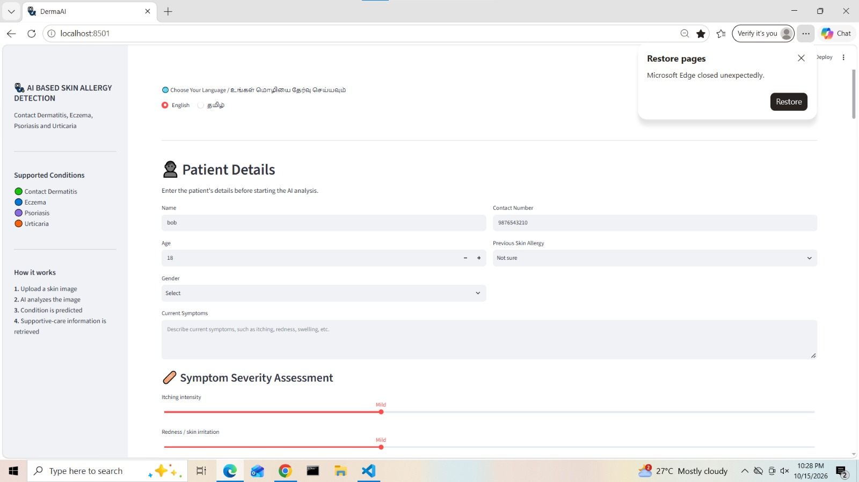

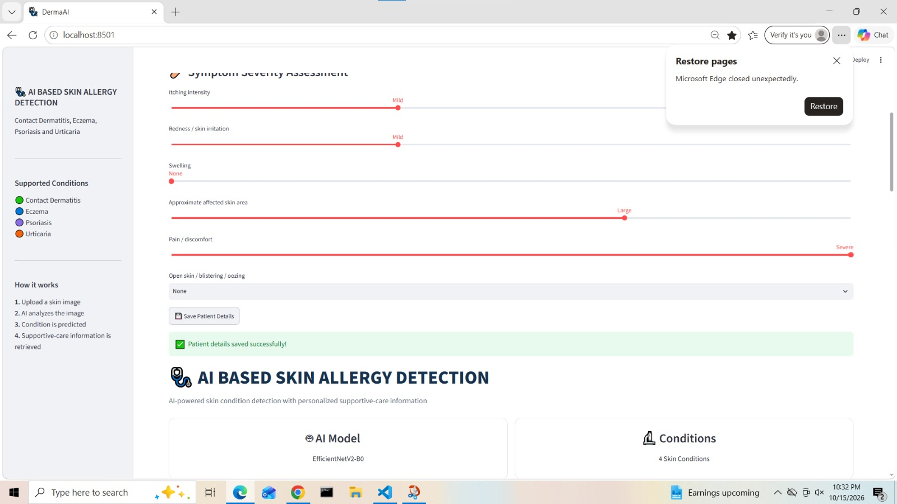

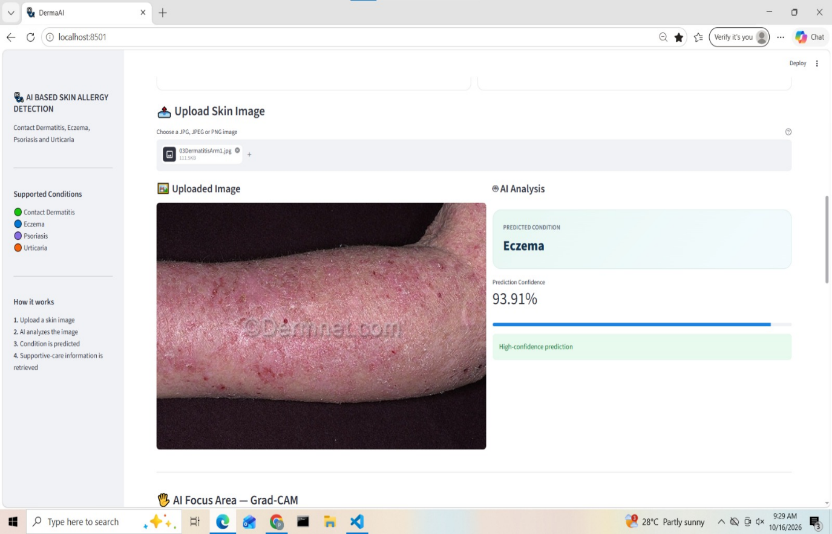

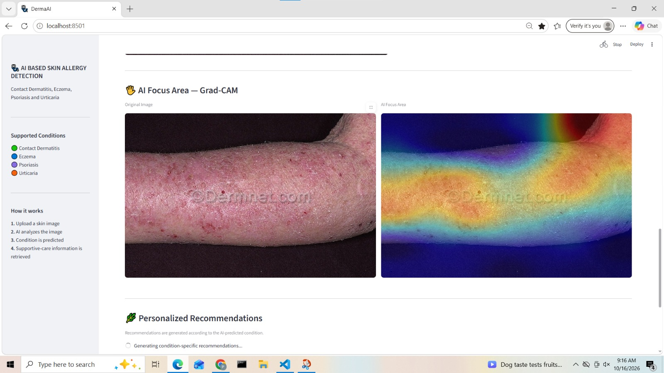

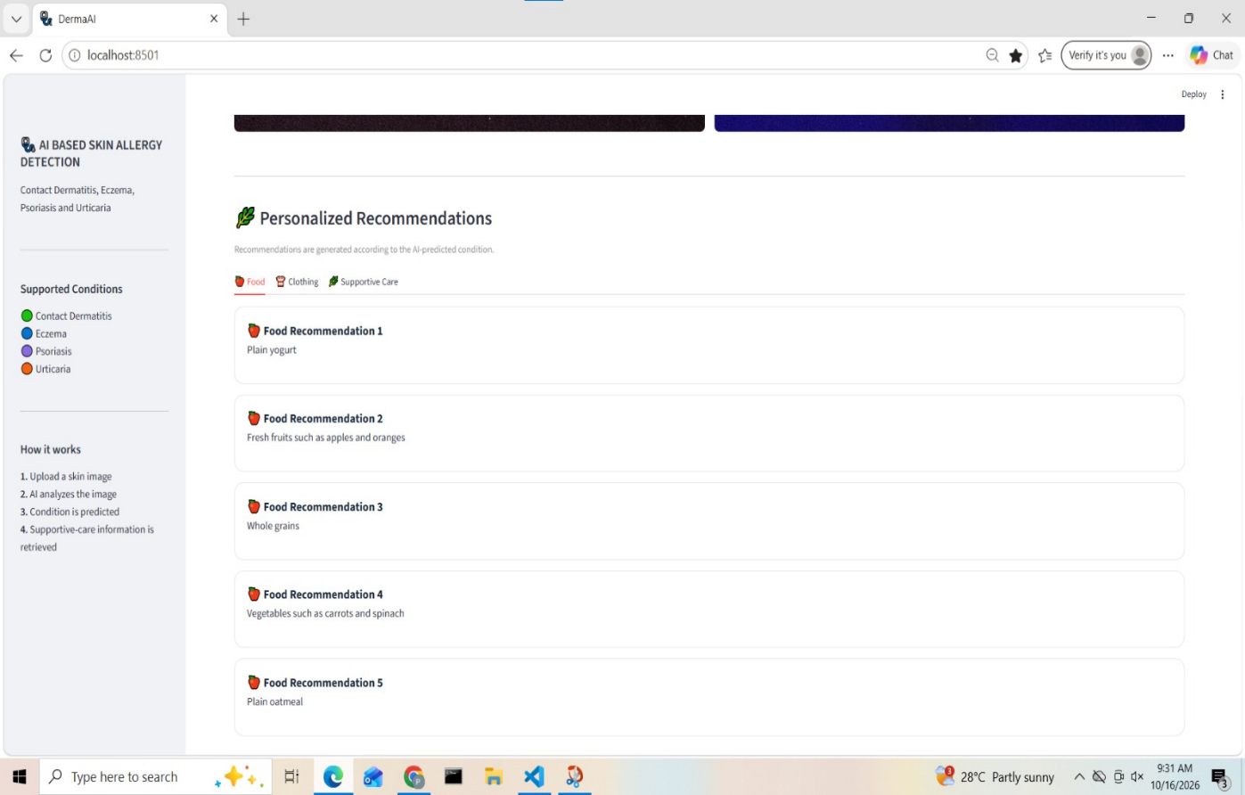

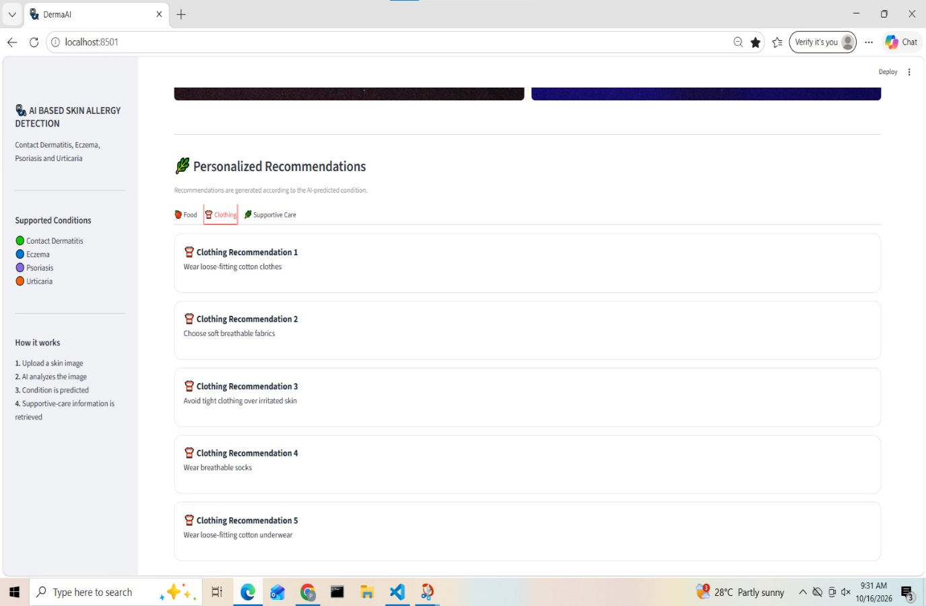

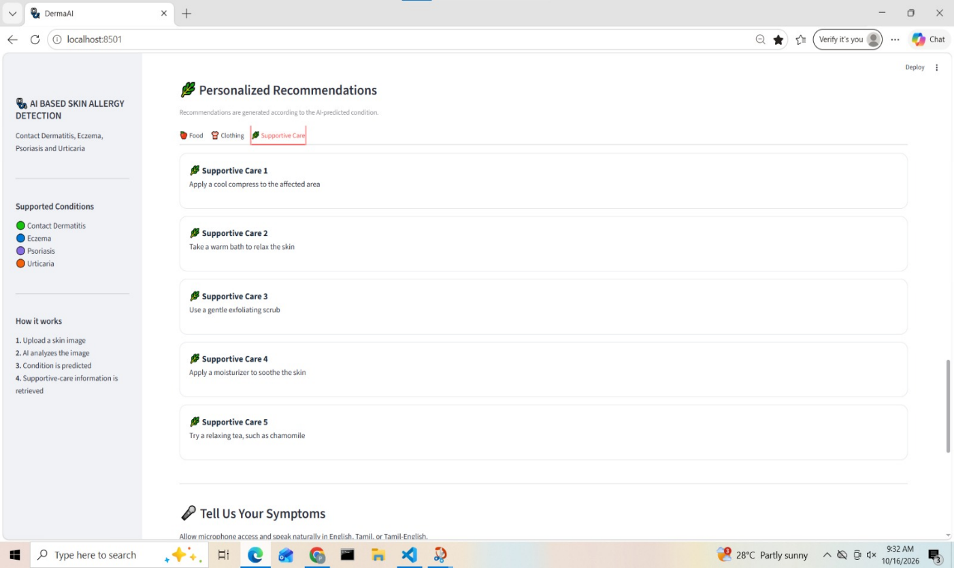

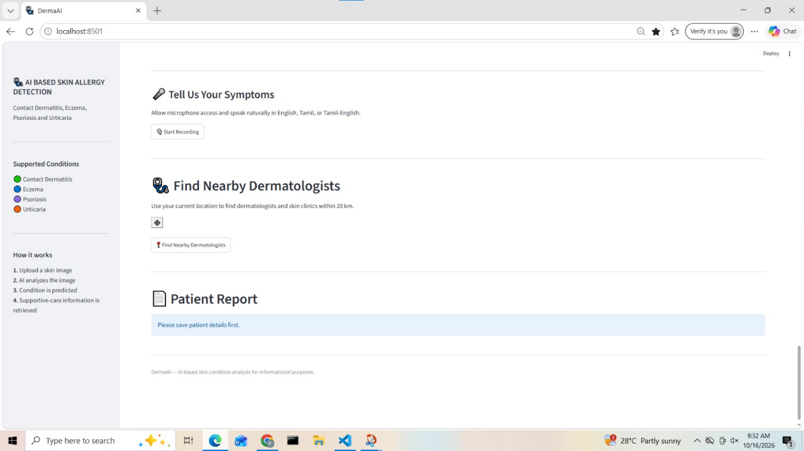

CONFERENCE APPLICATION



